Aim: Execute the following Linux commands: TTY Command, uname command, Date, cal, Whoami, Man, Pwd, Whatis, Fdisk, Sudo, Ifconfig, Chmod, Umask, Adduser, Ping, Hostname, Dpkg –l

# Learning Outcome: Able to work Linux environment by using Linux commands.

Duration: 8 Hour.

List of Hardware/Software requirements:

1. Computer Desktop/Laptop
2. Linux Operating System

# Code/Program/Procedure (with comment):

* tty

## tty

### There is a command called tty that displays terminal-related information.

### prints the file name of the terminal connected to standard input.

Output:

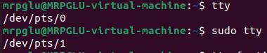

* uname

## uname

print information about the system.

Output:



* date

## date

display the system date and time.

Output:



* cal

## cal

if not working type

sudo apt install ncal

Output:

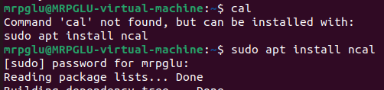

shows current month calendar as output

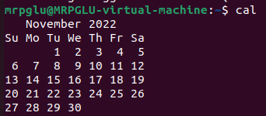

* whoami

## whoami

display the username of the current user.

Output:



* pwd

## pwd

print the full system path os the current working directory to standard output.

Output:



* umask

## umask

Set permission mask.

Output:



* hostname

## hostname

obtain the DNS name and set the system’s hostname or NIS

domain name.

Output:

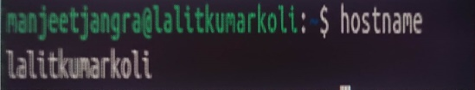

* ping
* ping google.com

contains the amount of time it takes for every packet to reach its destination and return.

Output:

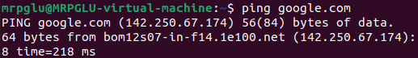

* man
* man man

it shows the manual pages of the command.

Output:

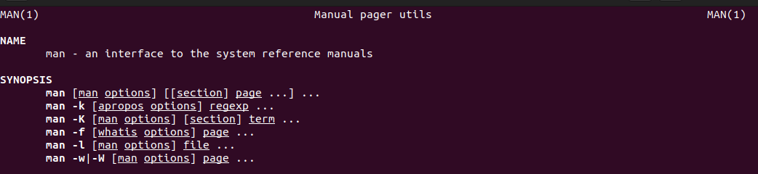

* whatis
* whatis

used to get a one-line manual page descriptions.

Output:



* fdisk
* fdisk --help

it is a command-line who show the options of disk.

Output:

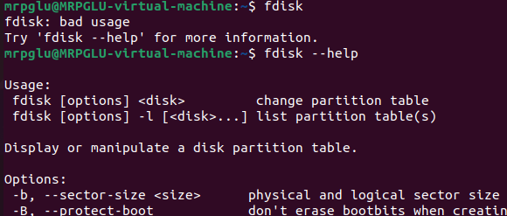

* sudo fdisk -l

it is a command-line partition table editor for Linux.

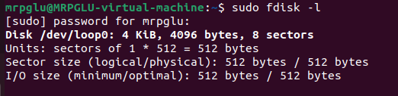

* sudo
* sudo

for any command to be done with administrative or root privileges.

Output:

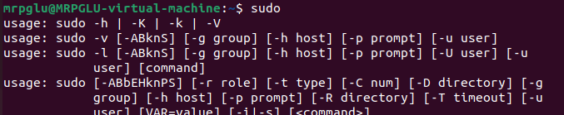

* ifconfig
* ifconfig

configure the kernel-resident network interfaces.

Output:

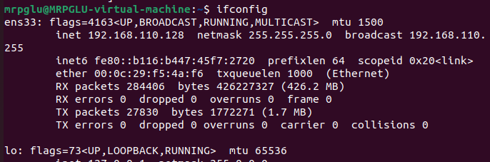

* chmod
* chmod gt.sh

to make a file executable and to change the permissions grated to it in Linux.

Output:



* adduser
* adduser

add/create a new user.

Output:



* dpkg -l
* dpkg -l

sorts thought a tree of Debian binary packages and creates a Packages file.

Output:

